Data Encrytion at Rest using gpg  
  
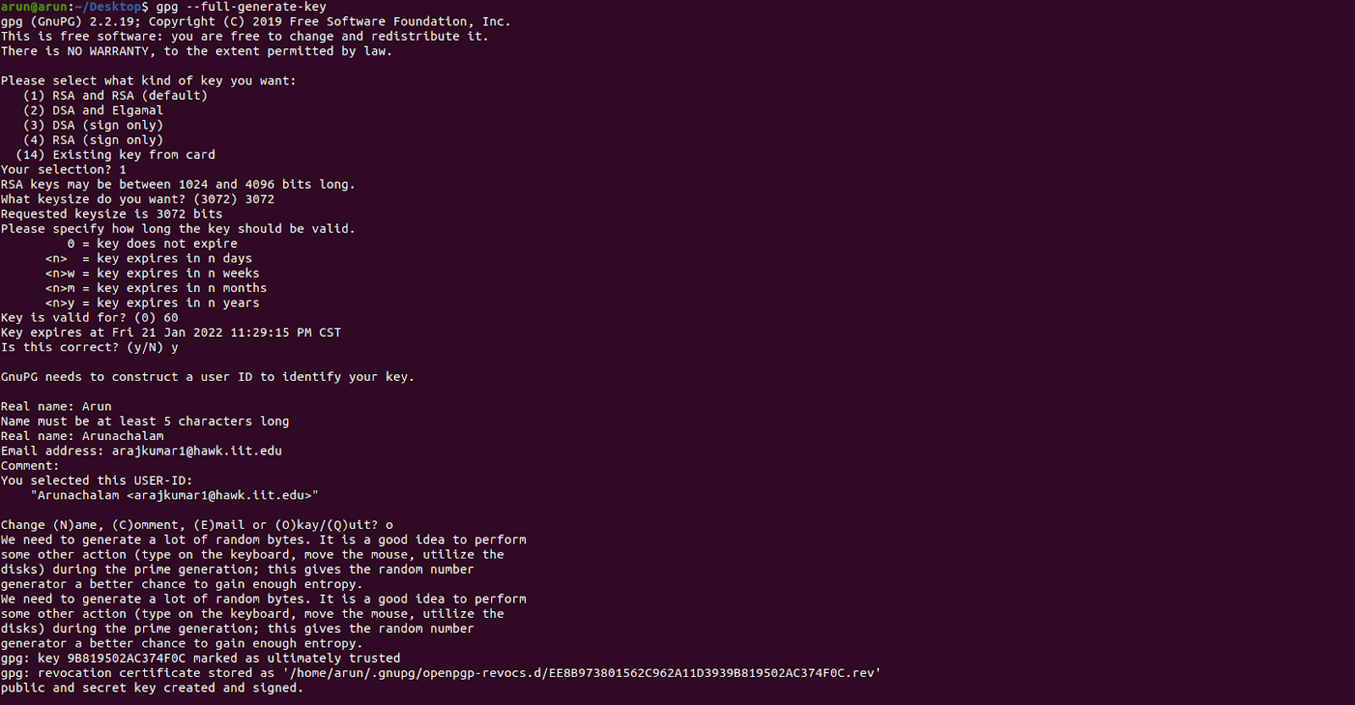  
  
  
  
  
  
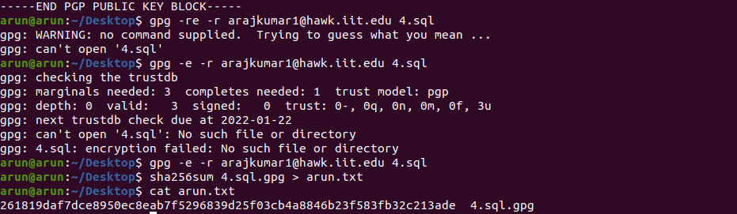  
  
  
Files after Encrypting 4.sql file using gpg  
  
